1. Open a new excel spreadsheet with three columns- Type, label, barcode
2. 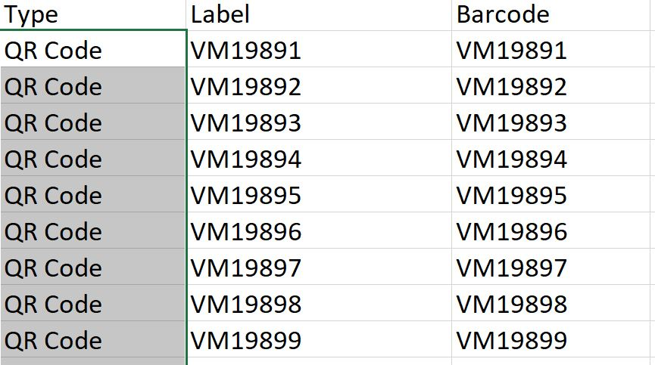In type- type in “QR Code”, in label- enter the label name, in barcode- enter the code (same as the label)
3. Save in a folder, and in the same folder, open up a word document with your barcode template
4. Go to mailings -> select recipients -> use an existing list, then select the excel sheet
5. After selecting your sheet, go back to the mailings tab, then go to the “insert merge field” dropdown, and insert “label” and “barcode”
6. 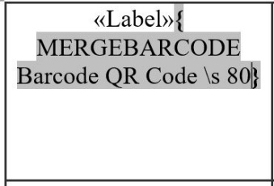\*Important\* in your box, right-click the <<Barcode>> label, and select “toggle field codes”, then type in the following in the box-
7. Right-click the code, the select “update field”
8. Go the next box, go back to the mailings tab->rules->select “Next Record”
9. Copy and paste the entire first box, and insert it into the next box after the “<<Next>>”
10. Copy and paste that box into the rest of the empty boxes
11. Go back to the mailings tab, go to “finish and merge,” then select “Edit individual documents,” then hit OK, and now you have your sheet of labels!